

实验（实习）报告

实验(实习)名称：实验三
日期：2022.5.17
学院：应用技术学院
专业：计算机科学与技术
班级：1班
姓名：成凯
学号：201833050025
指导教师：庞亚伟

- 实验目的
- 实验内容
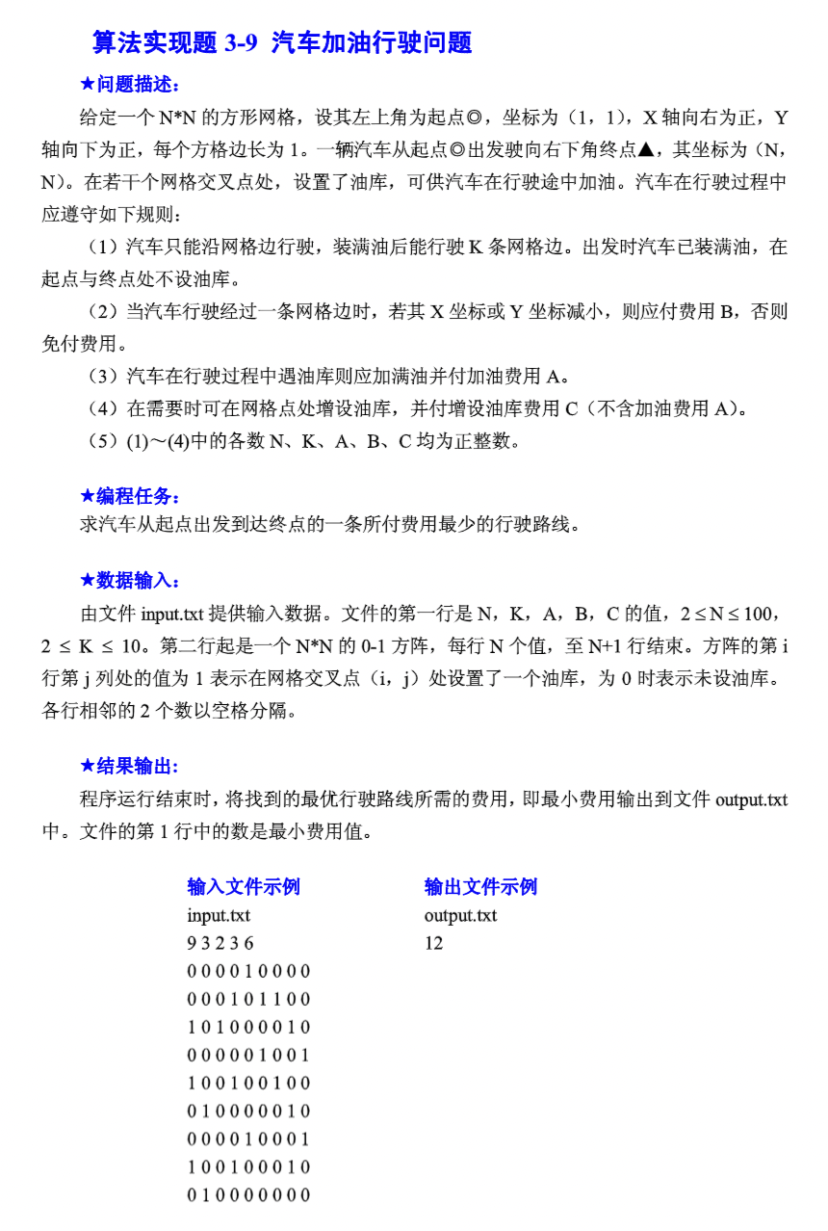

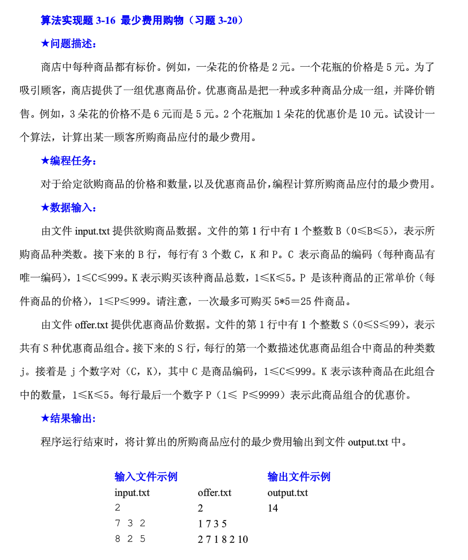

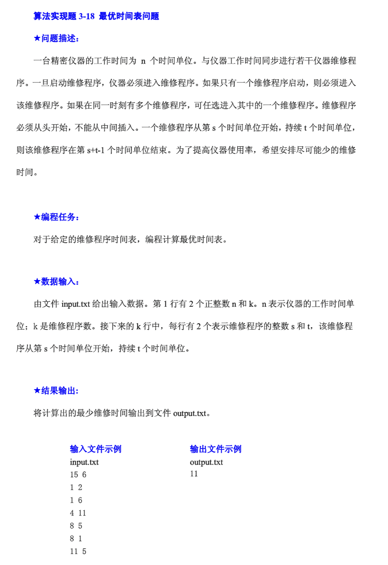

- 实验步骤和实验结果
算法一实现代码：
#include<cstdio>
#include<iostream>
#include<algorithm>
#include<cstring>
#include<queue>

#define maxn 1000010
#define maxm 3000010
#define inf 1000000000
using namespace std;
int head[maxn], dis[maxn], n, k, a, b, c, cnt;
bool inq[maxn];
int map[110][110];
struct edge {
int next;
int to;
int val;
} e[maxm];

void insert(int u, int v, int w) {
e[++cnt].next = head[u];
head[u] = cnt;
e[cnt].to = v;
e[cnt].val = w;
}

queue<int> q;

void spfa(int s) {
memset(dis, 0x3f, sizeof(dis));
memset(inq, false, sizeof(inq));
dis[s] = 0;
inq[s] = true;
q.push(s);
while (!q.empty()) {
int now = q.front();
q.pop();
inq[now] = false;
for (int i = head[now]; i; i = e[i].next) {
int v = e[i].to;
if (dis[v] > dis[now] + e[i].val) {
dis[v] = dis[now] + e[i].val;
if (!inq[v]) {
q.push(v);
inq[v] = true;
}
}
}
}
}

int getid(int x, int y, int level) {
return ((x - 1) * n + y) + n * n * (k - level);
}

int main() {
cin >> n >> k >> a >> b >> c;
for (int i = 1; i <= n; i++) {
for (int j = 1; j <= n; j++) scanf("%d", &map[i][j]);
}
for (int i = 1; i <= n; i++) {
for (int j = 1; j <= n; j++) {
if (map[i][j] == 1) {
for (int l = 0; l <= k - 1; l++) insert(getid(i, j, l), getid(i, j, k), a);
if (i < n) insert(getid(i, j, k), getid(i + 1, j, k - 1), 0);
if (j < n) insert(getid(i, j, k), getid(i, j + 1, k - 1), 0);
if (i > 1) insert(getid(i, j, k), getid(i - 1, j, k - 1), b);
if (j > 1) insert(getid(i, j, k), getid(i, j - 1, k - 1), b);

} else {
for (int l = 0; l <= k - 1; l++) insert(getid(i, j, l), getid(i, j, k), a + c);
for (int l = 1; l <= k; l++) {
if (i < n) insert(getid(i, j, l), getid(i + 1, j, l - 1), 0);
if (j < n) insert(getid(i, j, l), getid(i, j + 1, l - 1), 0);
if (i > 1) insert(getid(i, j, l), getid(i - 1, j, l - 1), b);
if (j > 1) insert(getid(i, j, l), getid(i, j - 1, l - 1), b);
}
}
}
}
spfa(getid(1, 1, k));
int ans = inf;
for (int i = 0; i <= k; i++) ans = min(ans, dis[getid(n, n, i)]);
cout << ans;

return 0;
}

算法一运行结果：
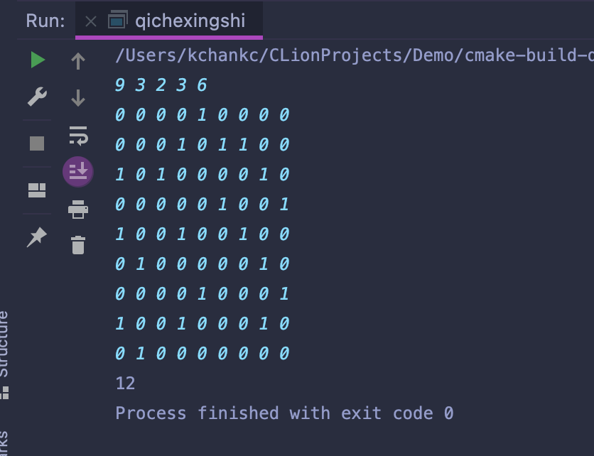

算法二实现代码：
#include <iostream>
#include <vector>
#include <algorithm>

using namespace std;
typedef pair<int, int> P;
const int MAX = 6;
const int INF = 1e9;
int map[1000];
int n, m;
int ids[MAX];
int price[MAX];
int nums[MAX];
vector<P> pairs[100];
int pP[100];
int pcnt = 0;
int dp[MAX][MAX][MAX][MAX][MAX];
int times = 0;

int dfs(int* x) {
times++;
int r = dp[x[0]][x[1]][x[2]][x[3]][x[4]];
if (r > 0) {
return (r);
}
if (x[0] == 0 && x[1] == 0 && x[2] == 0 && x[3] == 0 && x[4] == 0) {
return (0);
}
int minf = INF;
for (int i = 0; i < pcnt; i++) {
vector<P> &vec = pairs[i];
int f = 1;
int* y = new int[5];
for (int t = 0; t < 5; t++)
y[t] = 0;
for (auto p: vec) {
int id = map[p.first];
int num = p.second;
if (x[id] < num) {
f = 0;
break;
}
y[id] = -num;
}
if (!f)
continue;
for (int k = 0; k < 5; k++)
y[k] += x[k];
minf = min(minf, pP[i] + dfs(y));
}
int s = 0;
for (int i = 0; i < 5; i++) {
s += x[i] * price[i];
}
minf = min(minf, s);
return (dp[x[0]][x[1]][x[2]][x[3]][x[4]] = minf);
}

int main() {
cin >> n;
for (int i = 0; i < n; i++) {
int C, K, PP;
cin >> C >> K >> PP;
ids[i] = C;
nums[i] = K;
price[i] = PP;
if (!map[C]) {
map[C] = i;
}
}
cin >> m;
for (int i = 0; i < m; i++) {
int k;
cin >> k;
vector<P> v;
int f = 1;
for (int j = 0; j < k; j++) {
int a, b;
cin >> a >> b;
v.push_back(make_pair(a, b));
}
int PP;
cin >> PP;
if (f) {
pairs[pcnt] = v;
pP[pcnt++] = PP;
}
}
cout << "答案:" << dfs(nums) << endl;
cout << "运行次数:" << times << endl;
return (0);
}

算法二运行结果：
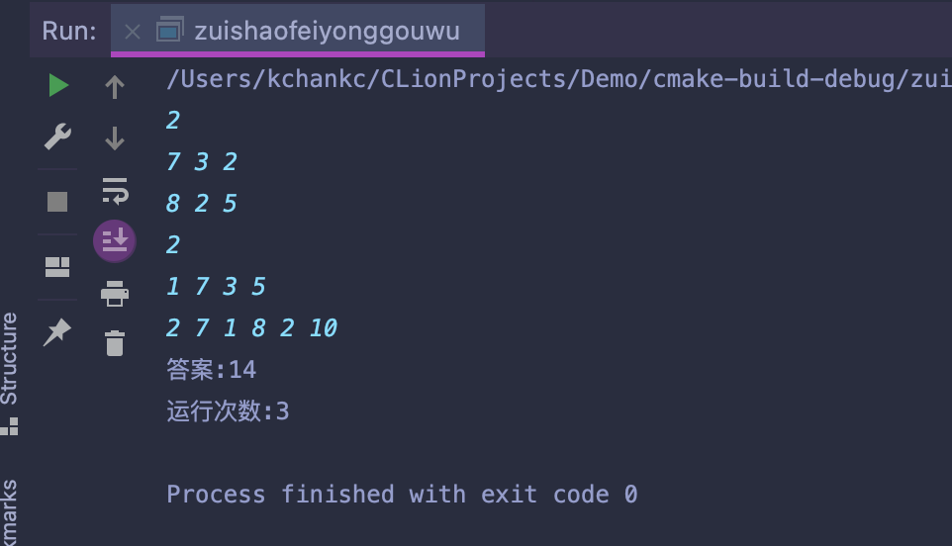

算法三实现代码：
#include <iostream>
#include <vector>
#include <cstring>

using namespace std;
const int MAXN = 2e5 + 100;
vector<int> vs[MAXN];
int dp[MAXN];

int main() {
int n, k, x, y;
cin >> n >> k;
for (int i = 0; i < k; i++) {
cin >> x >> y;
vs[x].emplace_back(y);
}
memset(dp, 0x3f, sizeof dp);
dp[n] = 0;
for (int i = n - 1; i > 0; i--) {
int len = vs[i].size();
if (len == 0) dp[i] = dp[i + 1];
else {
for (int j = 0; j < len; j++) {
int t = dp[i + vs[i][j]] + vs[i][j];
if (t <= n) {
dp[i] = min(dp[i], dp[i + vs[i][j]] + vs[i][j]);
} else {
dp[i] = min(dp[i], n);//不能超过n
}
}
}
}
cout << dp[1];
return 0;
}

算法三运行结果：
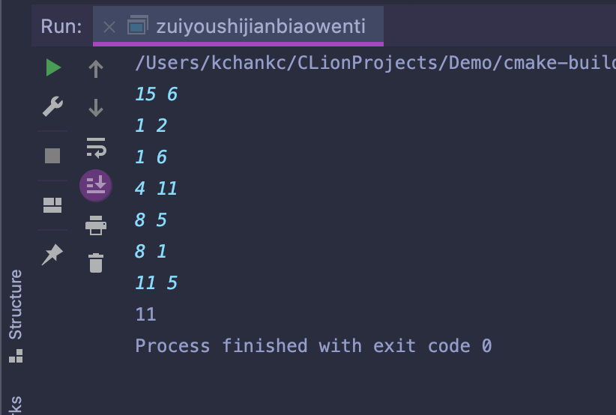

- 分析与讨论
通过本次实验加深了对动态规划算法的理解，透过本次实验让我受益匪浅。

